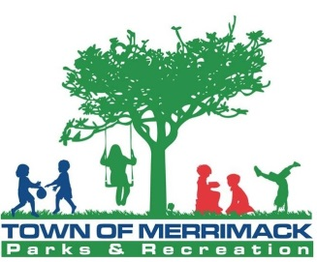
Wilderness First Aid
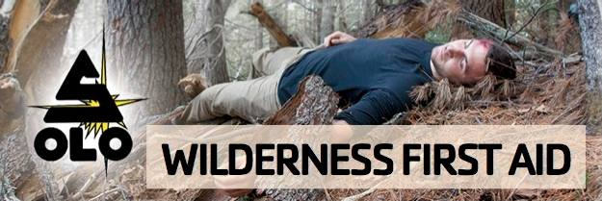
June 2nd – June 3rd, 2018

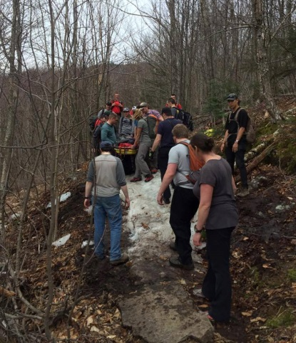
Do you like to spend time outdoors? Whether its hiking, biking, kayaking, rock climbing or other outdoor pursuits; if you or someone in your group got hurt would you know what to do? Accidents happen. People get hurt, sick, or lost. The temperature drops, the wind picks up, and it starts to rain.
Many back country emergencies are preventable and even when bad things happen, sometimes the wrong care can make things worse. By learning some valuable skills, you can make the difference between a good outcome and a bad one and maybe even save a life.
The Merrimack Parks & Recreation Department has teamed up with SOLO, a nationally recognized leaders in the field of wilderness medicine and rescue to provide affordable wilderness medical training close to home.
Wilderness First Aid is the perfect course for the outdoor enthusiast or trip leader who wants more than a basic level of first aid training for short trips with family, friends, and outdoor groups.
Wilderness First Aid is a comprehensive 16 hour long training program which focuses on the skills of: Response and Assessment, Musculoskeletal Injuries, Environmental Emergencies, Survival Skills, Soft Tissue Injuries, and Medical Emergencies.
This course will be held at Wasserman Park in Merrimack, NH and is approved by the American Camp Association and also by the NH Department of Environmental Services for Day Camp Health Center staffing requirements.
The cost of this valuable 2 day course is $150.00. Adult CPR/AED Course will be offered on Saturday, June 2nd for an additional fee of $50.00.
REQUIRMENTS FOR THIS COURSE: MUST have a current CPR certification upon completion of course. If you do not already hold the certification you must pay the additional $50.00 in order to sign up for CPR will be held on Saturday, evening. You cannot receive your wilderness first aid certification without having an up to date CPR certification by the end of the course.
Registrations are accepted by mail by completing the registration form on the back of this flyer or by visiting us online. Checks should be made payable to the Town of Merrimack. We encourage you to register early as spaces will fill up quickly!
For more INFORMATION or to register
Call: 603-882-1046 Email: mcasparius@merrimacknh.gov www.merrimackparksandrec.org
Registrations can be mailed to:
Merrimack Parks & Recreation, 116 Naticook Road, Merrimack, NH 03054
Merrimack Parks & Recreation
WILDERNESS MEDICINE TRAINING PROGRAM
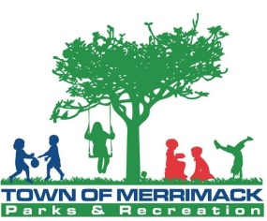
REGISTRATION FORM

Last Name: First Name:
Address: Town: State: Zip:
Home Telephone Number: Cell Telephone Number:
Gender: __M __ F Date of Birth (MM/DD/YY): / /
Email Address:
In the event of an emergency who is the best person to reach?
Name: Name:
Relationship to Participant: Relationship to Participant:
Home Telephone #: Home Telephone #:
Cell Phone #: Cell Phone #:
Work Telephone #: Work Telephone #:

WILDERNESS MEDICINE COURSES
PROGRAM NAME | PROGRAM DATES | FEE | SELECTION
Wilderness First Aid (WFA) | June 2nd – June 3rd | $150.00
Optional Heartsaver CPR/AED | June 2nd | $50.00

TOTAL AMOUNT ENCLOSED:

In consideration for my participation in programs sponsored by the Town of Merrimack, Parks and Recreation Department, I hereby release, waive, discharge and covenant not to sue the Town of Merrimack, its officials, employees, agents and representatives (hereinafter “Releasees”) from all liability to the undersigned, and his/her representatives, heirs, and successors in interest (hereinafter “undersigned”) for any and all loss or damage, and any claim or demands therefore on account of injury to the person or property of the undersigned, whether caused by the negligence of the Releasees or otherwise while the undersigned is participating in a program sponsored by the Town of Merrimack. I hereby agree to indemnify and save and hold harmless the releasees from any loss, injury, liability, damage or cost they may incur due to the presence of the undersigned in or about, or the undersigned’s use of, as a result of my participation in the Wilderness Medicine Training Program whether caused by the negligence of the Releasees or otherwise. I hereby assumes full responsibility for and risk of bodily injury or property damage, including but not limited to death, paralysis, brain injury, heart attack, stroke, aneurysm, broken bones, torn tendons or ligaments, torn muscles, spinal injury, damage to organs, disease, infection and any other physical or emotional injury, medical or psychiatric condition or complication of any kind whatsoever, due to any cause, including the negligence of Releasees or otherwise, while participating in the Town of Merrimack Parks & Recreation Department programs. I understand that by agreeing to this release of liability, I am waiving legal rights and/or remedies which may be available to me.
Signature: Date:
Registrations can be mailed to:
Merrimack Parks & Recreation, 116 Naticook Road, Merrimack, NH 03054

